Printing Files

With Google Docs

Print documents from a PDF or as a webpage. If you want to print directly from a PDF without choosing Print settings:
- From within the document you'd like to print, select Print from the File menu.
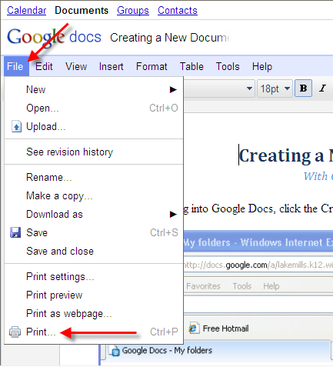

- A PDF appears with the print dialog box ready for printing.
Click the Printer icon button in the top left corner of the window.
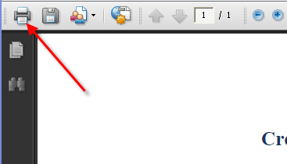
- The Print window will appear. In the Name field, click the down arrow to reveal a drop down list of network printers. Click to select a printer to print from.
Once satisfied with the settings, click OK at the bottom of the window to begin printing.
